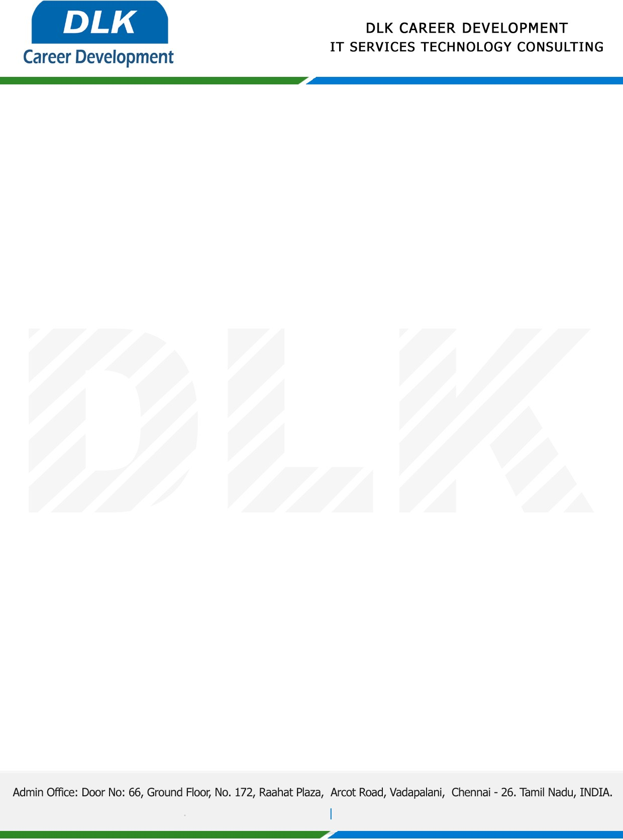

Date: 04 / January / 2023

**To**

Department of B.Tech ([Artificial Intelligence and Data Science),](https://www.cseindia.org/)

Head of Department,

Velammal Engineering College, Chennai - 600066.

**Sub: Letter of Internship Acceptance**

This is to certify that **MS LOHESWARI S A N (REG NO: 113220072018)** that third year student of has accepted her Internship Work duration from **06th January 2023** to **23rd January 2023** under the domain” **Android App Development”.** During the internship, all information and data collected from your should be kept confidential.

We appreciate your interest in **DLK CAREER DEVELOPMENT**

